1. **Write a program to find the length of the given string.**

.model small

.data

str db "What we know is a Drop;What we don't know is an Ocean$"

len db 0

b db "$"

.code

main proc near

mov ax,@data

mov ds,ax

lea si,str

mov bl,b

l1:

mov al,[si]

cmp al,bl

je Over

inc len

inc si

jmp l1

Over:

mov ah,04ch

int 21h

endp

end

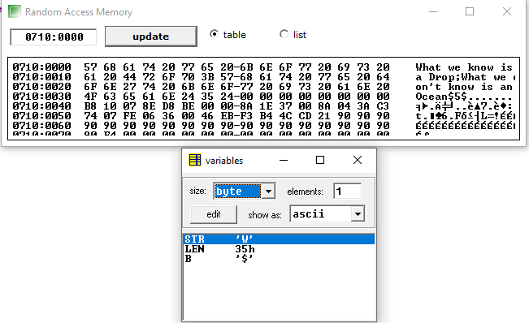

1. **Write a program to copy one string into another.**

.model small

.data

str db "What we know is a Drop;What we don't know is an Ocean$"

copy db 100 dup (?)

b db "$"

.code

main proc near

mov ax,@data

mov ds,ax

lea si,str

lea di,copy

mov bl,b

l1:

mov al,[si]

mov [di],al

cmp al,b

je Over

inc di

inc si

jmp l1

Over:

mov ah,04ch

int 21h

endp

end

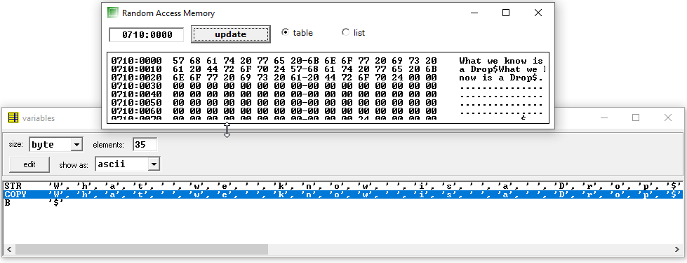

1. **Write a program to reverse a string into another string.**

.model small

.data

str db "What we know is a Drop$"

len db ?

rev db 100 dup (?)

b db "$"

.code

main proc near

mov ax,@data

mov ds,ax

lea si,str

mov bl,b

l1:

mov al,[si]

cmp al,b

je Over

inc len

inc si

jmp l1

Over:

lea di,rev

lea si,str+15h

mov cx,0000h

mov cl,len

l2:

mov al,[si]

mov [di],al

dec si

inc di

loop l2:

mov ah,04ch

int 21h

endp

end

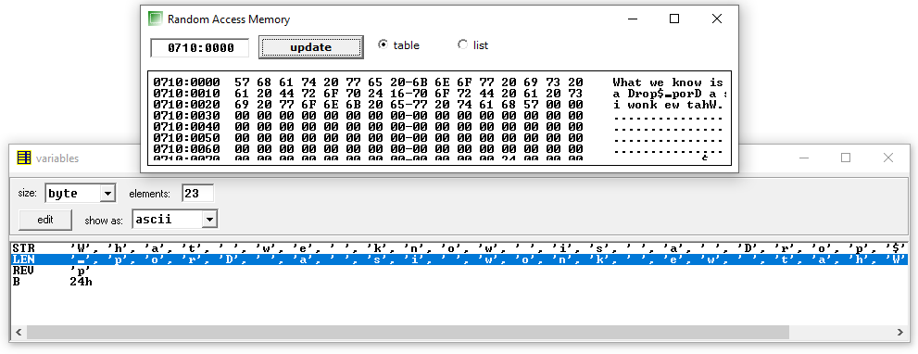

1. **Write a program to reverse a string and store it in the same string.**

.model small

.data

str db "What we know is a Drop$"

len dw ?

b db "$"

.code

main proc near

mov ax,@data

mov ds,ax

lea si,str

mov bl,b

l1:

mov al,[si]

cmp al,b

je Over

inc len

inc si

jmp l1

Over:

dec len

lea si,str

lea bx,str

add bx,len

mov di,bx

mov bx,0002h

mov cx,0000h

mov ax,len

div bx

mov cl,al

l2:

mov al,[si]

mov bl,[di]

mov [si],bl

mov [di],al

inc si

dec di

loop l2:

mov ah,04ch

int 21h

endp

end

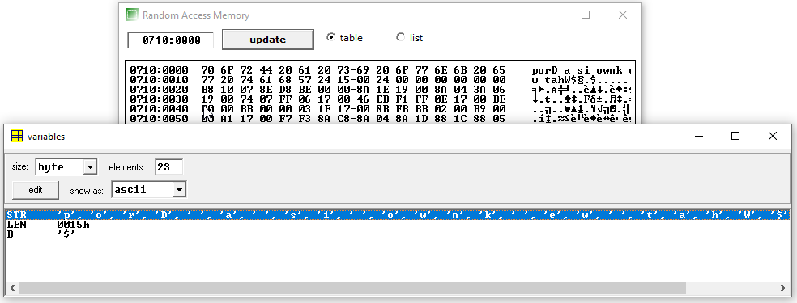

1. **Write all above programs using string instruction.**
2. **Write a program to find the length of the given string.**

.model small

.data

str db "I am vrcoder$"

len db ?

.code

main proc near

mov ax,@data

mov ds,ax

mov es,ax

mov ax,0000h

mov al,'$'

lea di,str

repnz scasb

mov bx,di

mov len,bl

mov ax,04ch

int 21h

endp

end

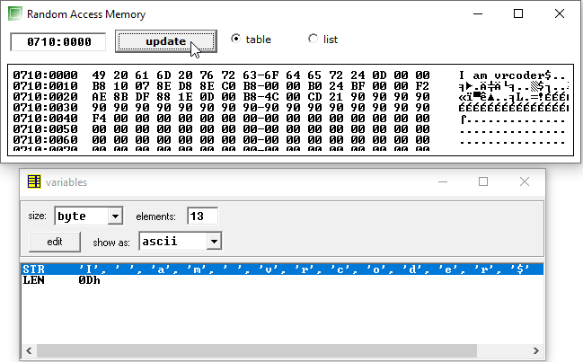

1. **Write a program to copy one string into another.**

.model small

.data

str db "I am vrcoder$"

copy db 50 dup (?)

.code

main proc near

mov ax,@data

mov ds,ax

mov es,ax

lea si,str

lea di,copy

repnz movsb

mov ax,04ch

int 21h

endp

end

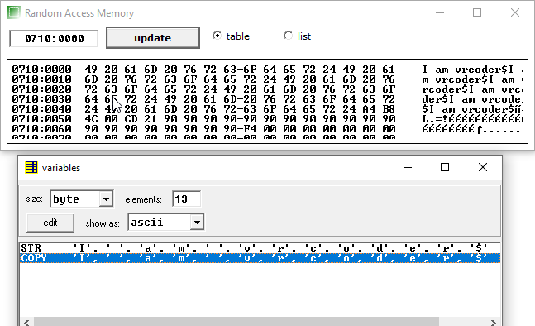

1. **Write a program to reverse a string into another string.**

.model small

.data

str db "I am vrcoder$"

len dw ?

rev db 50 dup (?)

.code

main proc near

mov ax,@data

mov ds,ax

mov es,ax

mov al,'$'

lea di,str

repnz scasb

mov bx,di

mov len,bx

dec len

lea bx,str

add bx,len

lea si,bx

lea di,rev

mov cx,len

inc cx

l1:

std

lodsb

cld

stosb

loop l1

mov ax,04ch

int 21h

endp

end

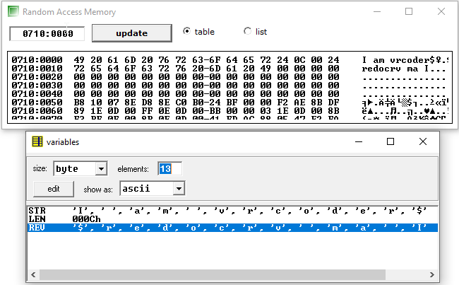

1. **Write a program to reverse a string and store it in the same string.**

.model small

.data

str db "I am vrcoder$"

len dw ?

.code

main proc near

mov ax,@data

mov ds,ax

mov es,ax

mov al,'$'

lea di,str

repnz scasb

mov ax,di

mov len,ax

mov bx,0002h

div bx

mov cl,al

mov ch,00h

dec len

lea bx,str

add bx,len

mov si,bx

lea di,str

l1:

mov bl,[di]

std

lodsb

cld

stosb

inc si

mov [si],bl

dec si

loop l1

mov ax,04ch

int 21h

endp

end

